RoadMap

Title: Comparative Study of Customer Segmentation Techniques Using Clustering Algorithms

Batch -3

2420030159-Dhanusha

2420030325-Nandini

2420030334-Lekha

Domain
Customer Analytics / Marketing Analytics

Dataset
I recommend using three benchmark datasets together:
- Mall Customer Segmentation Dataset (demographic and spending behavior)
https://www.kaggle.com/datasets/vjchoudhary7/customer-segmentation-tutorial-in-python
- Online Retail Dataset — UCI (transactional purchase data, ideal for RFM analysis)
https://archive.ics.uci.edu/dataset/352/online+retail
- Credit Card Customer Dataset (financial behavior and usage patterns)
https://www.kaggle.com/datasets/arjunbhasin2013/ccdata
All three are well-established, widely used datasets. All are to be considered in the project.

Abstract

Organizations across various industries generate large volumes of customer demographic, transactional, and behavioral data that can be utilized to understand customer purchasing patterns and support data-driven business decisions. However, traditional marketing strategies often treat customers as a single group, limiting the effectiveness of personalized marketing, customer retention, and business growth. To address this challenge, this project proposes a comprehensive customer segmentation framework by comparing multiple clustering algorithms through data analytics and visualization techniques.

The proposed framework utilizes three widely recognized benchmark datasets: the Mall Customer Segmentation Dataset, Customer Personality Analysis Dataset, and the UCI Online Retail Dataset. These datasets represent different customer perspectives, including demographic information, purchasing behavior, and transactional history, enabling a comprehensive analysis across multiple business scenarios. Initially, the datasets undergo data preprocessing, including missing value handling, duplicate removal, categorical data encoding, outlier detection, normalization, and feature scaling to improve data quality and consistency. A detailed Exploratory Data Analysis (EDA) is then performed to gain meaningful insights through dataset overview, data quality assessment, descriptive statistics, missing value analysis, duplicate record detection, outlier detection, univariate, bivariate, and multivariate analyses, correlation analysis, feature engineering, and feature selection.

Following preprocessing and EDA, multiple clustering algorithms, namely K-Means Clustering, Hierarchical Clustering, DBSCAN, and Gaussian Mixture Models (GMM), are implemented and evaluated for customer segmentation. The performance of these algorithms is assessed using standard clustering evaluation metrics, including the Silhouette Score, Davies–Bouldin Index, Calinski–Harabasz Index, execution time, and cluster quality. To enhance the interpretability of clustering results, the framework incorporates visualization techniques such as scatter plots, correlation heatmaps, boxplots, dendrograms, Elbow Method graphs, PCA/t-SNE visualizations, and interactive dashboards, enabling clear understanding of customer segments and algorithm performance.
Furthermore, a comparative analysis is conducted across all clustering algorithms to determine the most effective approach for different customer datasets. The comparison evaluates clustering accuracy, scalability, computational efficiency, and the ability to identify meaningful customer groups across demographic, behavioral, and transactional data.

The proposed research framework integrates customer analytics, data preprocessing, exploratory data analysis, unsupervised machine learning, clustering evaluation, and data visualization into a unified analytical pipeline. The project aims not only to identify the most suitable clustering algorithm for customer segmentation but also to provide actionable business insights that support personalized marketing strategies, customer relationship management, improved customer retention, and informed business decision-making across various industry sectors.
.

Approach

Data Analytics

EDA
Raw Customer Dataset
│
▼
Dataset Overview
│
▼
Data Quality Assessment
│
▼
Descriptive Statistics
│
▼
Missing Value Handling
│
▼
Duplicate Record Removal
│
▼
Outlier Detection
│
▼
Data Normalization / Feature Scaling
│
▼
Univariate Analysis
│
▼
Bivariate Analysis
│
▼
Multivariate Analysis
│
▼
Correlation Analysis
│
▼
Feature Engineering
│
▼
Feature Selection
│
▼
Clustering Algorithms
(K-Means, Hierarchical, DBSCAN, GMM)

Preprocessing
- Missing values
- Encoding (for any categorical features)
- Normalization / scaling
- Dimensionality reduction (PCA / t-SNE)

Clustering Algorithms
- K-Means
- Hierarchical Clustering
- DBSCAN
- Gaussian Mixture Model (GMM)
- Spectral Clustering
- Fuzzy C-Means (FCM)

Cluster Evaluation & Visualization
- Silhouette plots
- PCA / t-SNE cluster visualization
- Heatmap (feature means per cluster)
- Boxplot (feature distribution per cluster)
- Cluster profiling
- Dashboard

Comparative Analysis

Compare
- K-Means
- Hierarchical Clustering
- DBSCAN
- Gaussian Mixture Model
- Spectral Clustering
- Fuzzy C-Means (FCM)

Metrics
- Silhouette Score
- Davies-Bouldin Index
- Calinski-Harabasz Index
- Runtime / scalability

Recommended Research Pipelin
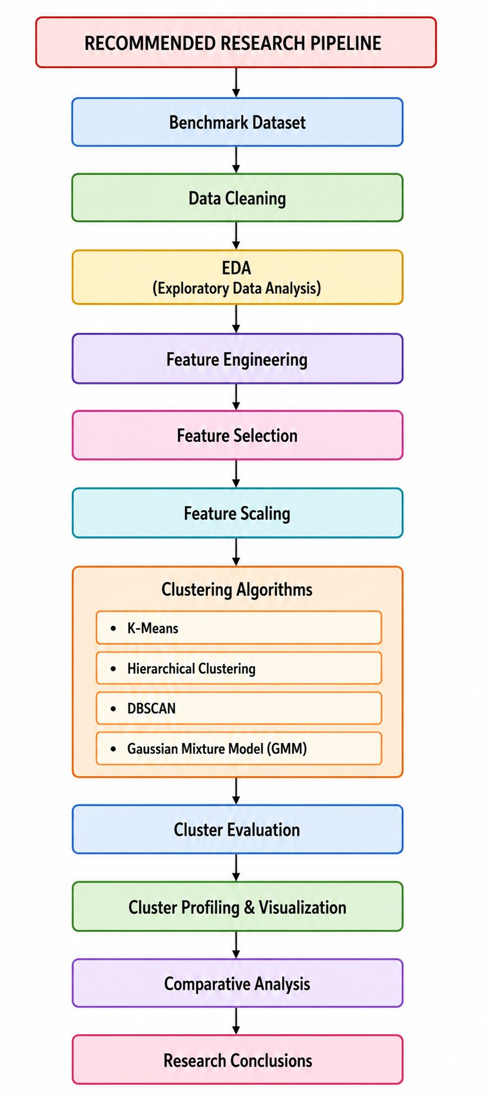

Note
This dataset combination is particularly strong because it covers demographic and spending profiles, transactional purchase behavior, and financial usage patterns. It enables meaningful comparisons of clustering techniques across different customer contexts, and is well aligned with current Customer Analytics, Marketing Analytics, and Unsupervised Learning research.

